

75th Concorso di Musica Viotti

11.-18.October （Vercelli-Italy）

https://www.concorsoviotti.it/en/about_us_home/



10th Renata Tebaldi International Voice Competition（Baroque Section）

23.-27. September 2025 (San Marino -Italy)

https://www.fondazionerenatatebaldi.org

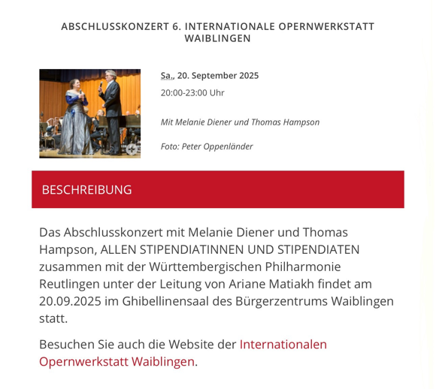

AbschlussKonzert 6 International Opernwerkstatt Waiblingen

20.September 2025 (Waiblingen-Detuschland)

https://www.internationale-opernwerkstatt-waiblingen.de/willkommen

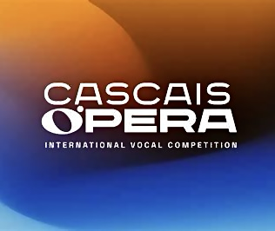

2nd Cascais Opera International Vocal Competition

23.April-4.May (Cascais-Portugal)

https://cascaisopera.com

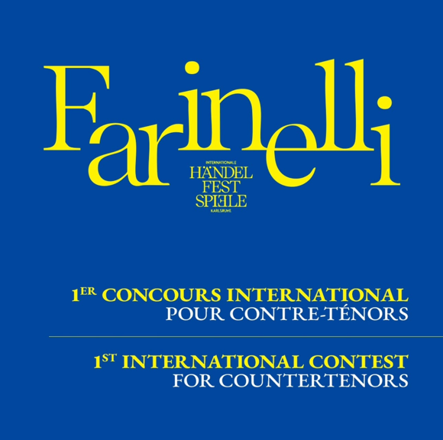

Farinelli Wettbewerb

27.February-02.March (Karlsruhe-Deutschland)

https://www.staatstheater-karlsruhe.de/programm/oper/farinelli-wettbewerb/

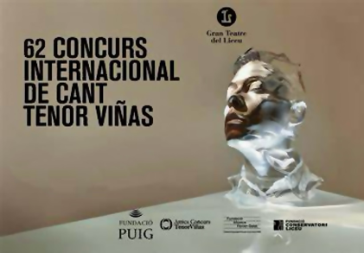

62nd Tenor Viñas Concurs

18.-26. January (Barcelona-Spain)

https://www.tenorvinas.com/en

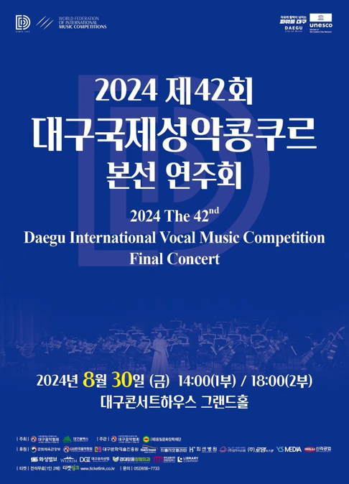

Daegu International Vocal music Competition Finalist Concert

30.August 2024 (Daegu-Korea)

https://daegumusic.com

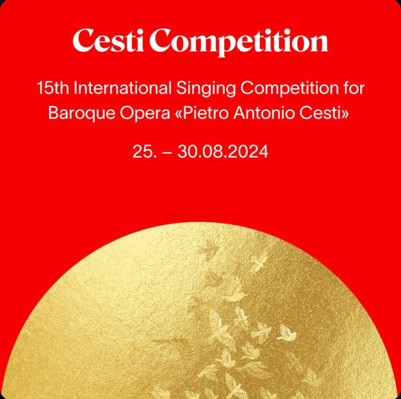

15th International Singing Competition for Baroque Opera《Antonio Cesti》

25.-30.August (Innsbruck-Austria）

https://www.altemusik.at/en/cesti

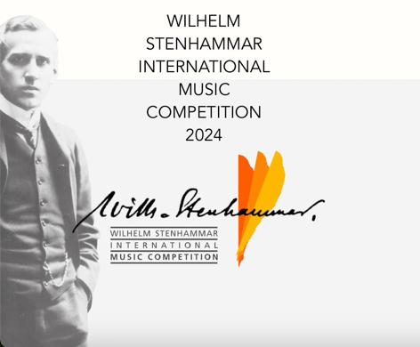

Wilhelm Stenhammar International Music Competition

07.-13.June 2024 (Norrköping-Sweden)

https://www.stenhammarcompetition.se

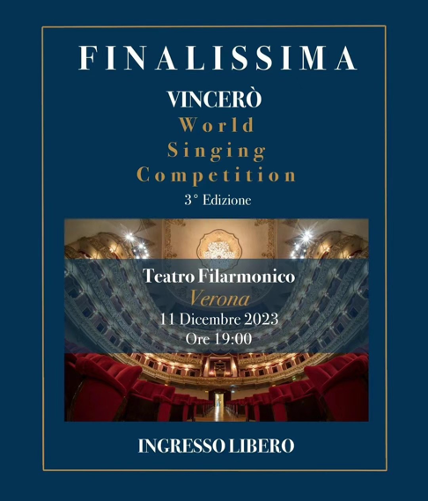

3rd Vincerò World Singing Competition Finalist Concert

11.December 2023 (Verona-Italy)

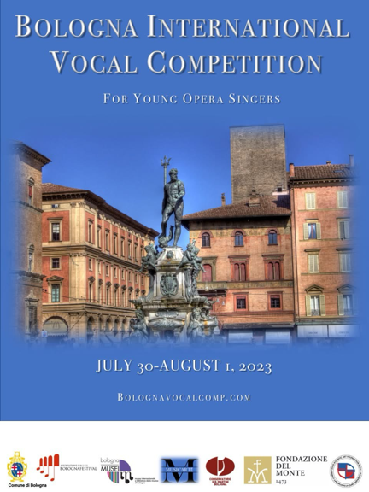

Bologna International Vocal Competition Winners' Performance

01.August 2023 (Bologna-Italy)

https://bolognavocalcomp.com



Gound Opera: Romeo et Juliette (Stephone)

30.June-01.July 2023 (ShangHai-China)



Special concert by Baroque Chamber Orchestra of Shanghai Conservatory of Music

Alto Solo-The Fairy Queen

12.June 2023 (ShangHai-China)

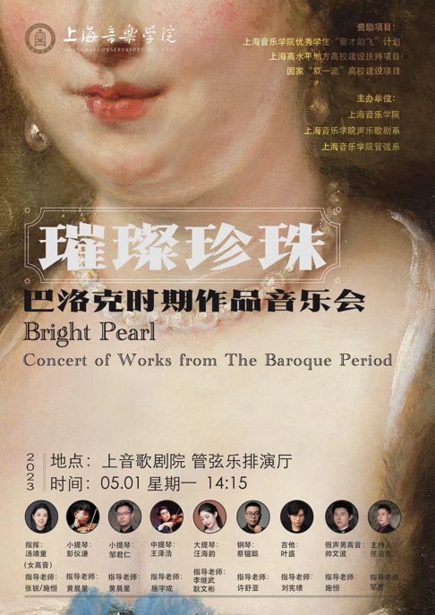

Bright Pearl-Concert of Works from Baroque Period

01.May 2023 （ShangHai-China）



60th Tenor Viñas Concurs

21.-27.January (Barcelona-Spain）

https://www.tenorvinas.com/en

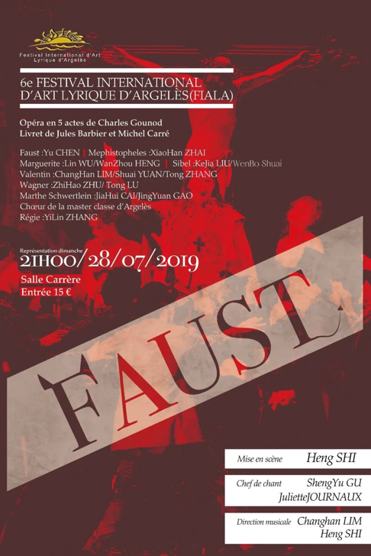

Gound Opera:Faust (Siebel)

07.August 2019 (ShangHai-China)